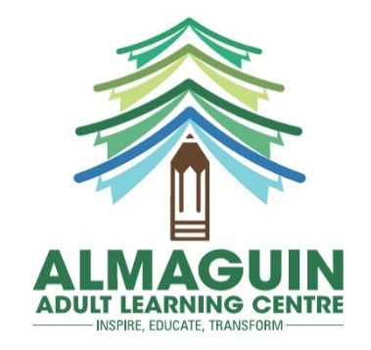

**Adult Literacy Instructor Intern**

**One Year Contract**

**South River, Burk’s Falls and Powassan**

Job Description:   
Almaguin Adult Learning Centre requires a full-time Adult Literacy Instructor Intern for their literacy and basic skills upgrading program.

Placement at the South River, Burk’s Falls and Powassan locations, with occasional coverage for holidays and sick days. Flexibility is required to accommodate changing schedules.

Possible call in work to follow, i.e. sick days, vacations etc.

The position requires:

* Facilitating in-person and virtual learning for small groups of multi-level, mixed aged adults (anywhere from basic reading and writing to secondary school level curriculum, as well as computer instruction, financial literacy, and employment skills.
* Conducting initial, ongoing and exit assessments.
* Developing and updating training plans.
* Keeping and updating student records.
* Assisting in fundraising campaigns; identify and support applications for alternate funding resources.
* Assisting in developing and implementing strategies for outreach to new clients and partner agencies.
* A high degree of proficiency in MS Office and social media platforms, and virtual meeting and communication platforms.
* Must be either a new entrant into the workforce, transitioning to a new career, or unemployed or underemployed and entering a new field,
* Has not previously participated in NOHFC’s People & Talent Program,
* Must be at least 18 years of age,
* Must reside in Northern Ontario,
* Must be legally entitled to work in Canada,

Qualifications:

Must have a vehicle and driver’s licence

Completed Covid vaccinations

Pay Rate: $16 per hour, 35 hours per week, Monday to Friday

Application Deadline: Friday, January 28,2022

Please email applications, including a cover letter and a resume to the attention of Deb Kurtzer-Johnston at [learningworks@bellnet.ca](mailto:learningworks@bellnet.ca) or Fax: 705-386-0029

Almaguin Adult Learning Centre would like to thank all respondents, but only those chosen for an interview will be contacted.

This opportunity is proudly supported by:

cid:3b0a36ec-5799-4e06-9ed7-00cc120ef60c 